April 3, 2026
GOOD FRIDAY
6:30 pm

t

OVERVIEW
Tenebrae (Latin for "darkness") was the name given to the medieval predawn morning prayer celebrated by monks during the last three days in Holy Week. In recent centuries, this monastic liturgy—despite its early morning light imagery—was transferred to Wednesday evening in Holy Week. In the monastic practice, it was a service of prayers and readings from scripture. As the light began to dawn, the candles used for reading were gradually extinguished, so that at the end of the service, the rising sun provided the necessary light for reading and singing.

In the service presented here, the extinguishing of candles has been placed within the narrative of Jesus Christ’s final words from the cross. With this form seven candles are used. Following each section one of the candles are extinguished.

Rather than "mourning" the dying or dead Jesus on Good Friday, the cross is acclaimed as the sign of the world's redemption. The procession of the cross and adoration of the crucified Christ become the primary symbolic action of this day. We offer honor and reverence to the one who, lifted up from the earth, draws all people to Himself. This service does not end in darkness and sadness, as if the assembly were reenacting the death of Christ. Rather, the liturgy ends with Christ exalted on the cross, an image from John's gospel.

GATHERING
(All gather in silence. The assembly will stand when Pastor stands)

THE OPENING HYMN “Lamb of God, Pure and Sinless” LSB 434
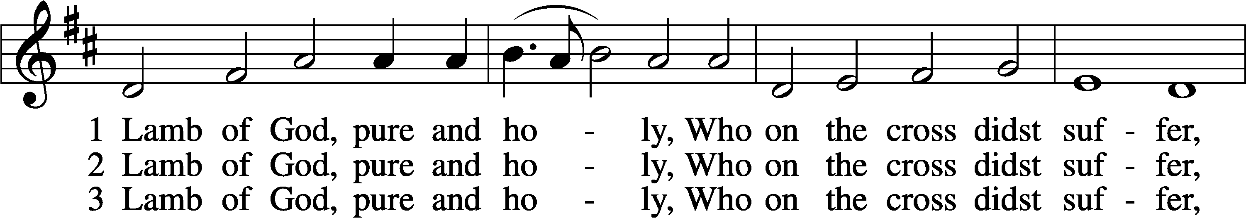
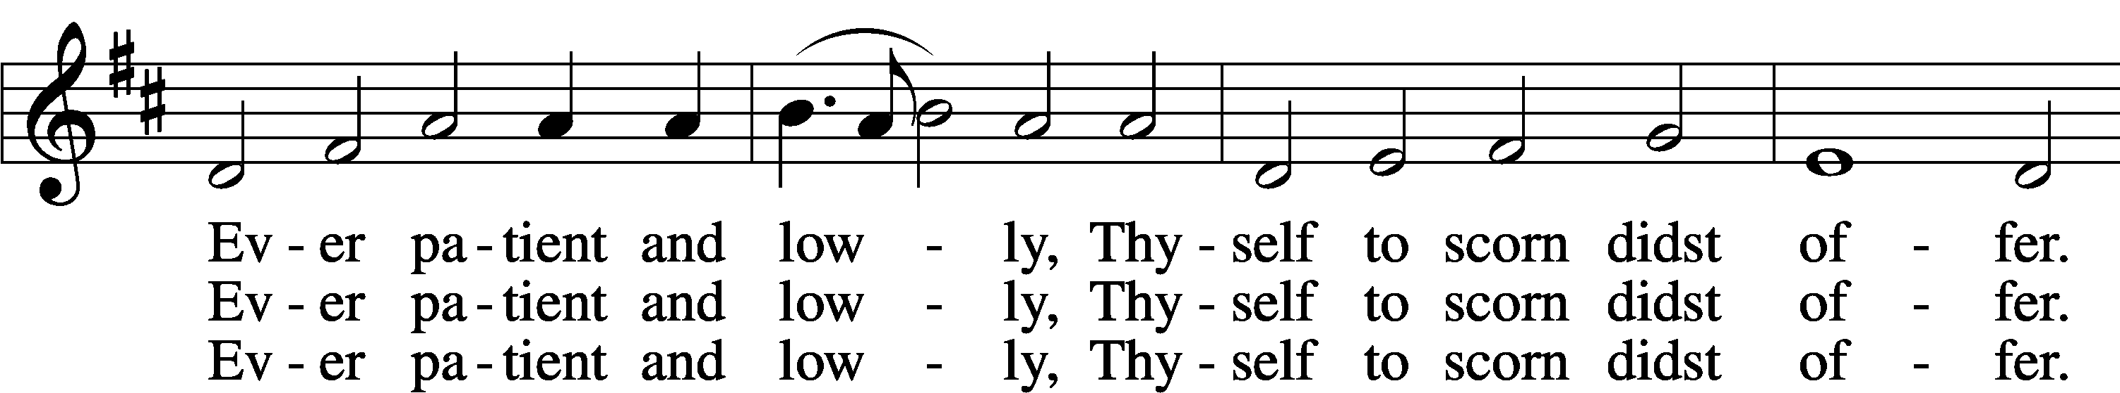
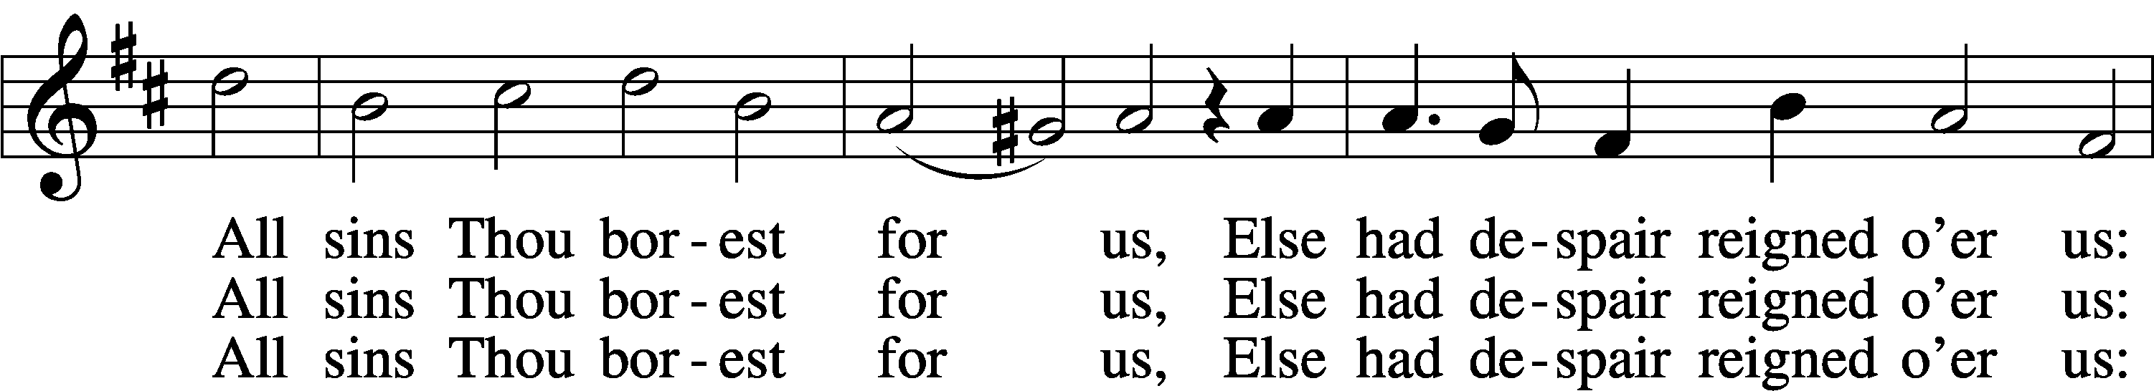
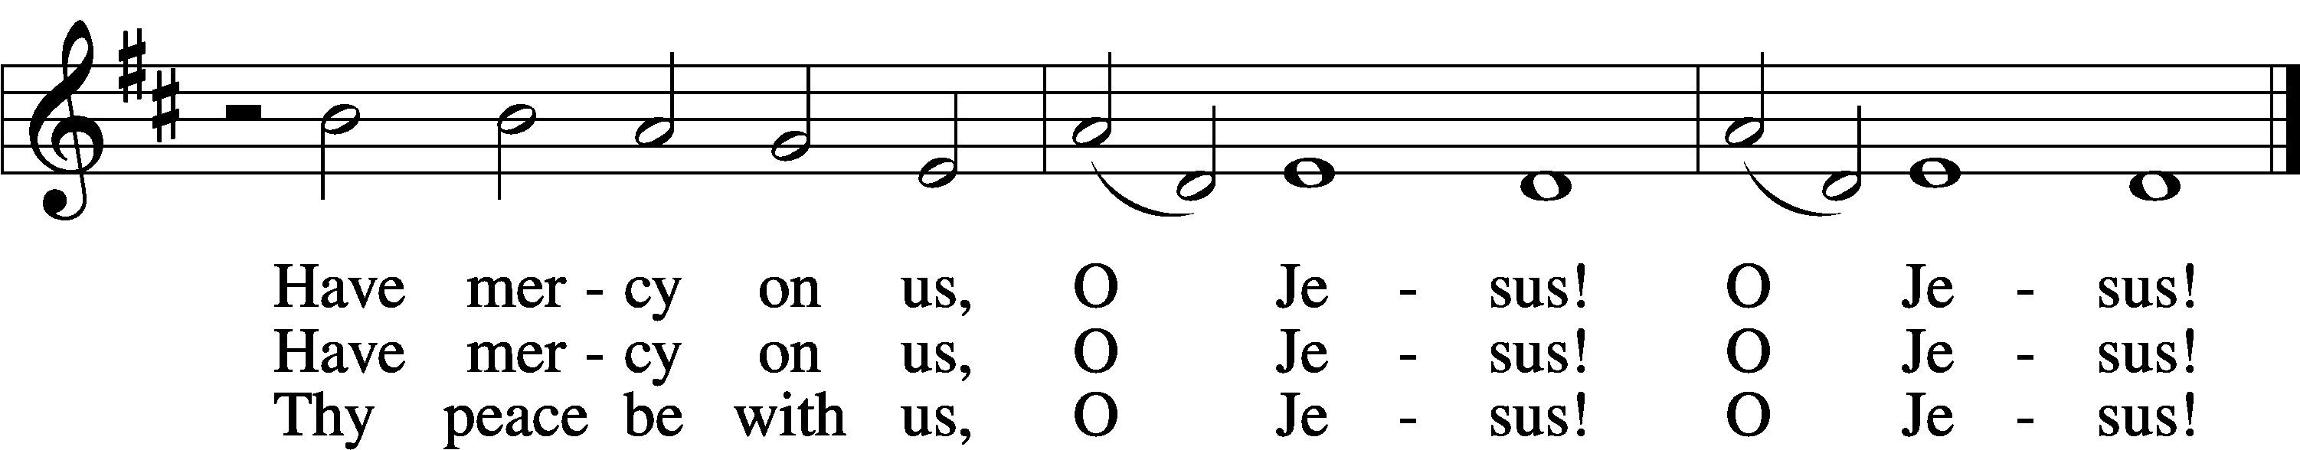
Text and tune: Public domain

PRAYER OF THE DAY
P Almighty God, look with loving mercy on your family, for whom our Lord Jesus Christ was willing to be betrayed, to be given over to the hands of sinners, and to suffer death on the cross; who now lives and reigns with you and the Holy Spirit, one God, forever and ever.
C Amen

READING Isaiah 52:13—53:122
¹³Behold, my servant shall act wisely; he shall be high and lifted up, and shall be exalted.
¹⁴ As many were astonished at you— his appearance was so marred, beyond human semblance,
and his form beyond that of the children of mankind—
¹⁵ so shall he sprinkle many nations. Kings shall shut their mouths because of him, for that
which has not been told them they see,and that which they have not heard they understand.
53 ¹Who has believed what he has heard from us?
And to whom has the arm of the Lord been revealed?
² For he grew up before him like a young plant, and like a root out of dry ground; he had no form or majesty that we should look at him, and no beauty that we should desire him.
³ He was despised and rejected by men, a man of sorrows and acquainted with grief; and as one from whom men hide their faces he was despised, and we esteemed him not.
⁴ Surely he has borne our griefs and carried our sorrows; yet we esteemed him stricken,
smitten by God, and afflicted.
⁵ But he was pierced for our transgressions; he was crushed for our iniquities; upon him was the
chastisement that brought us peace, and with his wounds we are healed.
⁶ All we like sheep have gone astray; we have turned—every one—to his own way; and
the Lord has laid on him the iniquity of us all.
⁷ He was oppressed, and he was afflicted, yet he opened not his mouth; like a lamb that is led
to the slaughter, and like a sheep that before its shearers is silent, so he opened not his mouth.
⁸ By oppression and judgment he was taken away; and as for his generation, who considered
that he was cut off out of the land of the living, stricken for the transgression of my people?
⁹ And they made his grave with the wicked and with a rich man in his death, although he had
done no violence, and there was no deceit in his mouth.
¹⁰ Yet it was the will of the Lord to crush him; he has put him to grief; when his soul makes an
offering for guilt, he shall see his offspring; he shall prolong his days; the will of the Lord shall
prosper in his hand.
¹¹ Out of the anguish of his soul he shall see and be satisfied; by his knowledge shall the
righteous one, my servant, make many to be accounted righteous, and he shall bear their
iniquities.
¹² Therefore I will divide him a portion with the many, and he shall divide the spoil with the
strong, because he poured out his soul to death and was numbered with the transgressors;
yet he bore the sin of many, and makes intercession for the transgressors.

(The Reading is followed by a time of silent reflection)

THE BIDDING PRAYER

(The assembly stands for Prayer)
P Let us pray, brothers and sisters, for the holy church throughout the world.
C Amen
(Silent prayer)
P Almighty and eternal God, you have shown your glory to all nations in Jesus Christ. By your Holy Spirit guide the church and gather it throughout the world. Help it to persevere in faith, proclaim your name, and bring the good news of salvation in Christ to all people. We ask this through Christ our Lord.
C Amen
(Silent prayer)
P Almighty and eternal God, your Spirit guides the church and makes it holy.
Strengthen and uphold our bishops, pastors, other ministers, and lay leaders. Keep them in health and safety for the good of the church, and help each of us in our various vocations to do faithfully the work to which you have called us. We ask this through Christ our Lord.
C Amen

P Let us pray for those preparing for baptism.
(Silent prayer)
P Almighty and eternal God, you continue to bless the church. Increase the faith and understanding of those preparing for baptism. Give them new birth as your children, and keep them in the faith and communion of your holy church. We ask this through Christ our Lord.
C Amen

P Let us pray for our sisters and brothers who share our faith in
Jesus Christ.
(Silent prayer)

P Almighty and eternal God, you give your church unity. Look with favor on all who follow Jesus your Son. Make all the baptized one in the fullness of faith, and keep us united in the fellowship of love. We ask this through Christ our Lord.
C Amen

P Let us pray for the Jewish people, the first to hear the word of God.
(Silent prayer)
P Almighty and eternal God, long ago you gave your promise to Abraham and your teaching to Moses. Hear our prayers that the people you called and elected as your own may receive the fulfillment of the covenant's promises. We ask this through Christ our Lord.
C Amen

P Let us pray for those who do not share our faith in Jesus Christ.
(Silent prayer)
P Almighty and eternal God, gather into your embrace all those who call out to you under different names. Bring an end to inter-religious strife, and make us more faithful witnesses of the love made known to us in your Son. We ask this through Christ our Lord.
C Amen

P Let us pray for those who do not believe in God.
(Silent prayer)
P Almighty and eternal God, you created humanity so that all may long to know you and find peace in you. Grant that all may recognize the signs of your love and grace in the world and in the lives of Christians, and gladly acknowledge you as the one true God. We ask this through Christ our Lord.
C Amen

P Let us pray for God's creation.
(Silent prayer)
C Almighty and eternal God, you are the creator of a magnificent universe. Hold all the worlds in the arms of your care and bring all things to fulfillment in you. We ask this through Christ our Lord.
Amen.

P Let us pray for those who serve in public office.
(Silent prayer)
P Almighty and eternal God, you are the champion of the poor and oppressed. In your goodness, give wisdom to those in authority, so that all people may enjoy justice, peace, freedom, and a share in the goodness of your creation.
We ask this through Christ our Lord.
C Amen

P Let us pray for those in need.
(Silent prayer)
P Almighty and eternal God, you give strength to the weary and new courage to those who have lost heart. Heal the sick, comfort the dying, give safety to travelers, free those unjustly deprived of liberty, and deliver your world from falsehood, hunger, and disease. Hear the prayers of all who call on you in any trouble, that they may have the joy of receiving your help in their need. We ask this through Christ our Lord.
C Amen

THE LORD’S PRAYER Matthew 6: 9–13
C Our Father who art in heaven, hallowed be Thy name, Thy kingdom come, Thy will be done on earth as it is in heaven; give us this day our daily bread; and forgive us our trespasses as we forgive those who trespass against us; and lead us not into temptation, but deliver us from evil. For Thine is the kingdom and the power and the glory forever and ever. Amen.

HYMN “Jesus, I will Ponder Now” LSB 440, v.1

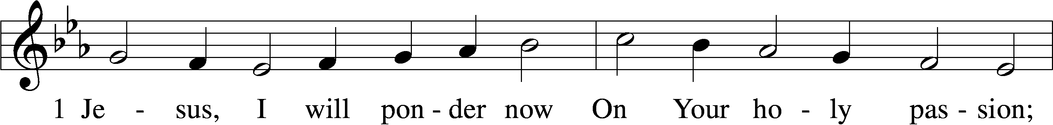
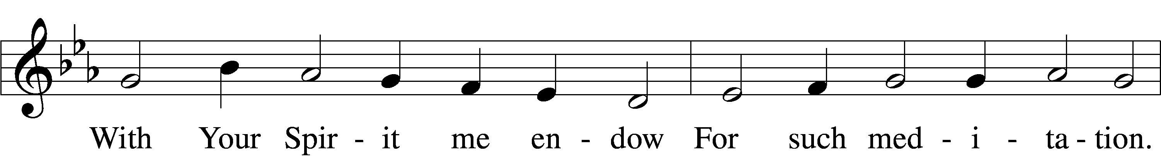
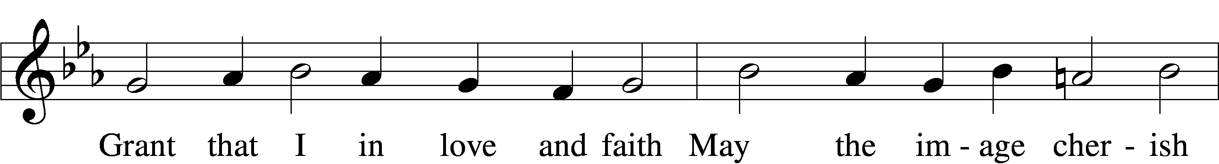
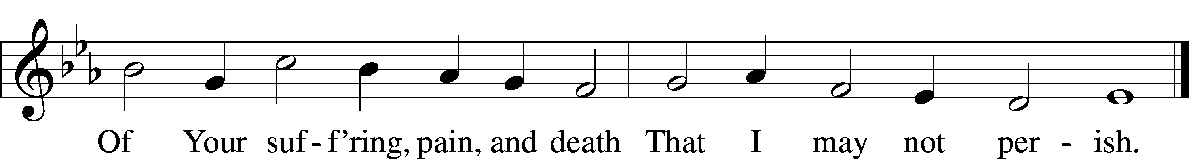
Text and tune: Public domain

THE PASSION ACCORDING TO ST. JOHN, PART ONE John 18:1–11
¹After Jesus had spoken these words, he went out with his disciples across the Kidron valley to a place where there was a garden, which he and his disciples entered. ²Now Judas, who betrayed him, also knew the place, because Jesus often met there with his disciples. ³So Judas brought a detachment of soldiers together with police from the chief priests and the Pharisees, and they came there with lanterns and torches and weapons. ⁴Then Jesus, knowing all that was to happen to him, came forward and asked them, "Whom are you looking for?" ⁵They answered, "Jesus of Nazareth." Jesus replied, "I am he." Judas, who betrayed him, was standing with them. ⁶When Jesus said to them, "I am he," they stepped back and fell to the ground. ⁷Again he asked them, "Whom are you looking for?" And they said, "Jesus of Nazareth." ⁸Jesus answered, "I told you that I am he. So if you are looking for me, let these men go." ⁹This was to fulfill the word that he had spoken, "I did not lose a single one of those whom you gave me." ¹⁰Then Simon Peter, who had a sword, drew it, struck the high priest's slave, and cut off his right ear. The slave's name was Malchus. ¹¹Jesus said to Peter, "Put your sword back into its sheath. Am I not to drink the cup that the Father has given me?"

HYMN “Jesus, I will Ponder Now” LSB 440, v.2

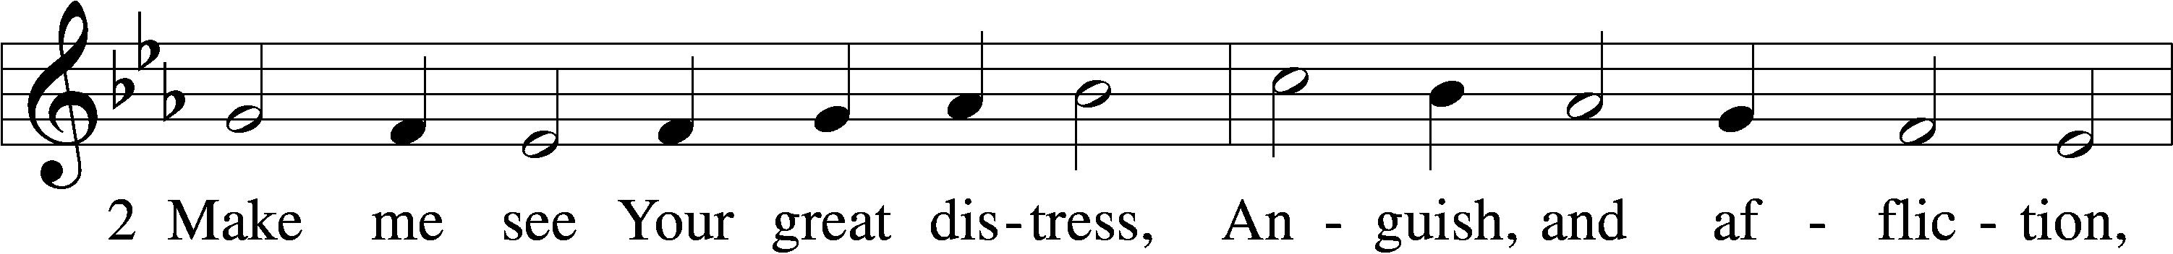
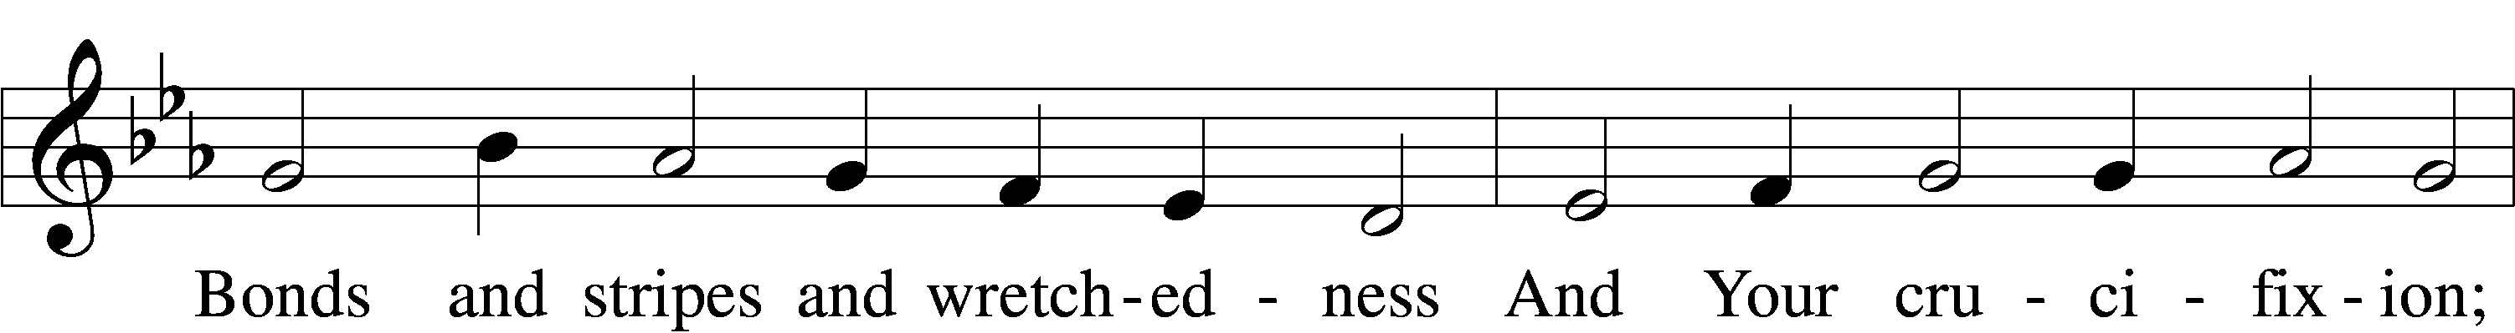
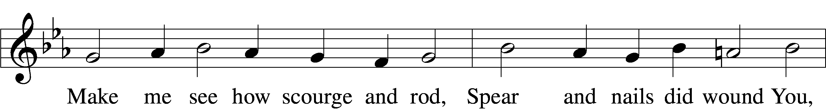
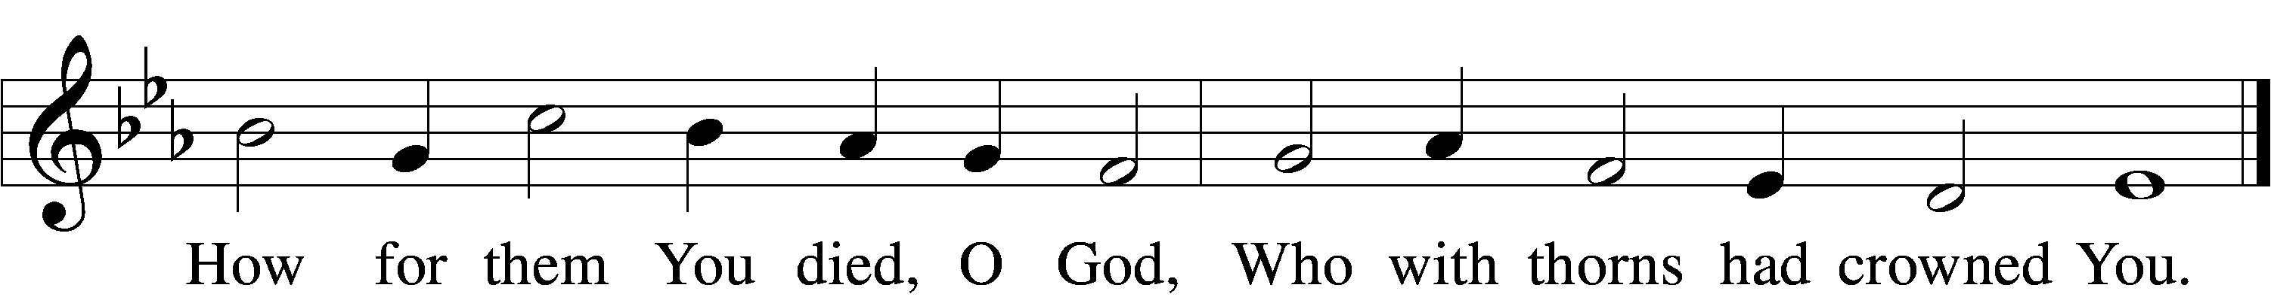
Text and tune: Public domain
–

THE PASSION ACCORDING TO ST. JOHN, PART TWO John 18:12–27
¹²So the soldiers, their officer, and the Jewish police arrested Jesus and bound him. ¹³First they took him to Annas, who was the father-in- law of Caiaphas, the high priest that year. ¹⁴Caiaphas was the one who had advised the Jews that it was better to have one person die for the people.
¹⁵Simon Peter and another disciple followed Jesus. Since that disciple was known to the high priest, he went with Jesus into the courtyard of the high priest, ¹⁶but Peter was standing outside at the gate. So the other disciple, who was known to the high priest, went out, spoke to the woman who guarded the gate, and brought Peter in. ¹⁷The woman said to Peter, "You are not also one of this man's disciples, are you?" He said, "I am not." ¹⁸Now the slaves and the police had made a charcoal fire because it was cold, and they were standing around it and warming themselves. Peter also was standing with them and warming himself.
¹⁹Then the high priest questioned Jesus about his disciples and about his teaching. ²⁰Jesus answered, "I have spoken openly to the world; I have always taught in synagogues and in the temple, where all the Jews come together. I have said nothing in secret. ²¹Why do you ask me? Ask those who heard what I said to them; they know what I said." ²²When he had said this, one of the police standing nearby struck Jesus on the face, saying, "Is that how you answer the high priest?" ²³Jesus answered, "If I have spoken wrongly, testify to the wrong. But if I have spoken rightly, why do you strike me?" ²⁴Then Annas sent him bound to Caiaphas the high priest. ²⁵Now Simon Peter was standing and warming himself. They asked him, "You are not also one of his disciples, are you?" He denied it and said, "I am not." ²⁶One of the slaves of the high priest, a relative of the man whose ear Peter had cut off, asked, "Did I not see you in the garden with him?" ²⁷Again Peter denied it, and at that moment the cock crowed.

HYMN “Jesus, I will Ponder Now” LSB 440, v.3
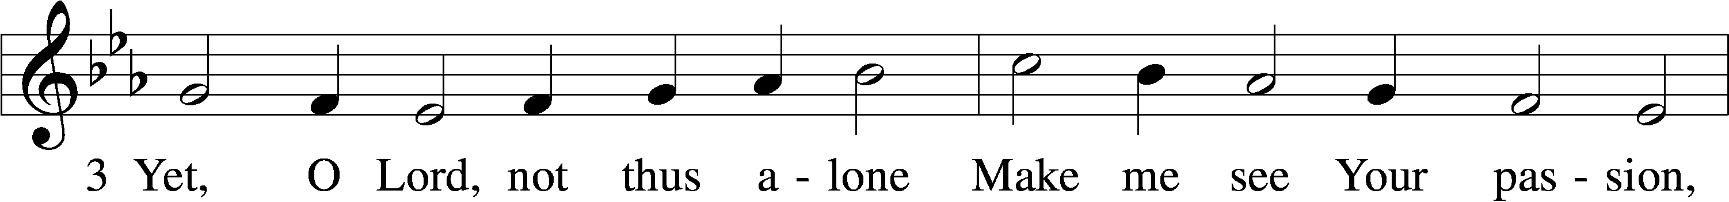
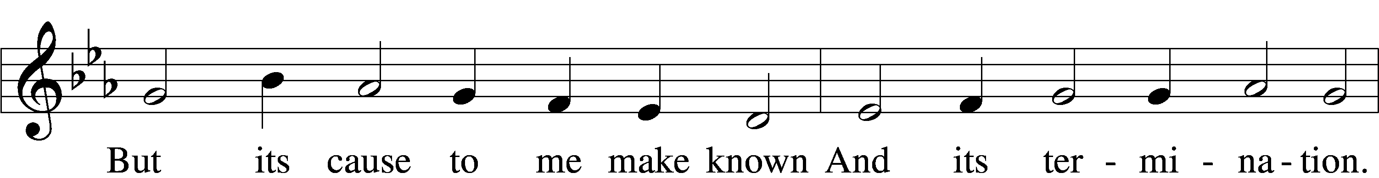
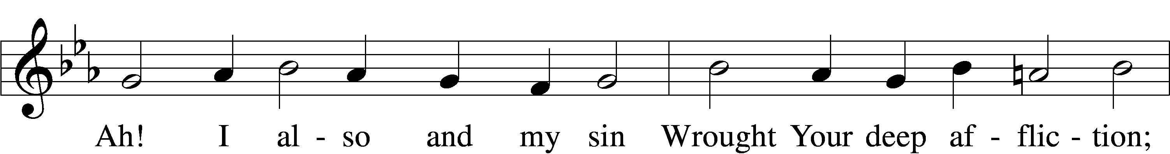
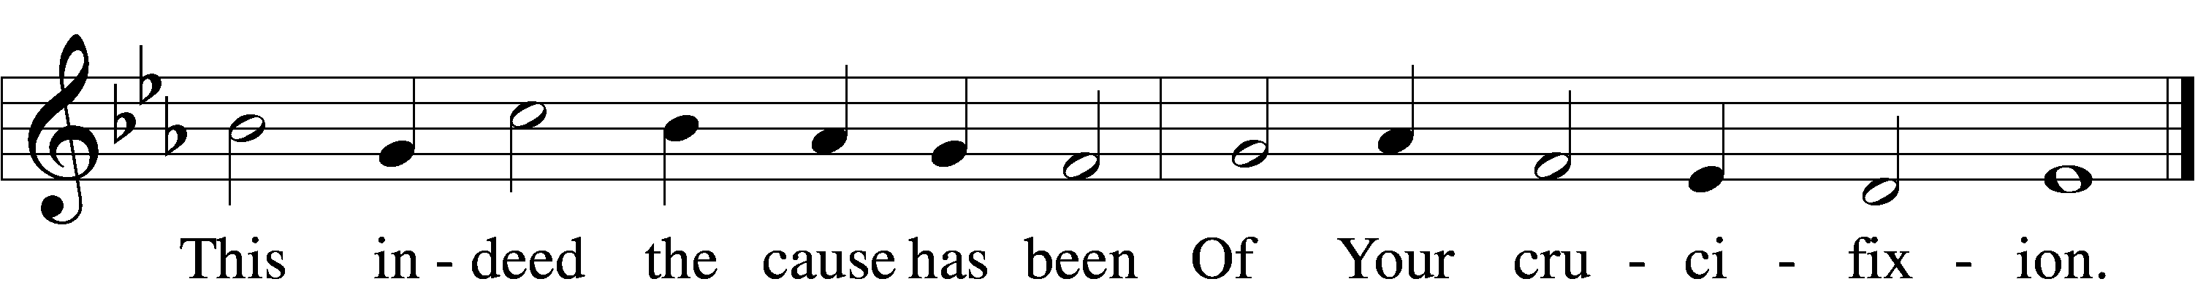
Text and tune: Public domain

THE PASSION ACCORDING TO ST. JOHN, PART THREE John 18:28–40
²⁸Then they took Jesus from Caiaphas to Pilate's headquarters. It was early in the morning. They themselves did not enter the headquarters, so as to avoid ritual defilement and to be able to eat the Passover. ²⁹So Pilate went out to them and said, "What accusation do you bring against this man?" ³⁰They answered, "If this man were not a criminal, we would not have handed him over to you." ³¹Pilate said to them, "Take him yourselves and judge him according to your law." The Jews replied, "We are not permitted to put anyone to death." ³²(This was to fulfill what Jesus had said when he indicated the kind of death he was to die.)
³³Then Pilate entered the headquarters again, summoned Jesus, and asked him, "Are you the King of the Jews?" ³⁴Jesus answered, "Do you ask this on your own, or did others tell you about me?" ³⁵Pilate replied, "I am not a Jew, am I? Your own nation and the chief priests have handed you over to me. What have you done?" ³⁶Jesus answered, "My kingdom is not from this world. If my kingdom were from this world, my followers would be fighting to keep me from being handed over to the Jews. But as it is, my kingdom is not from here." ³⁷Pilate asked him, "So you are a king?" Jesus answered, "You say that I am a king. For this I was born, and for this I came into the world, to testify to the truth. Everyone who belongs to the truth listens to my voice." ³⁸Pilate asked him, "What is truth?"
After he had said this, he went out to the Jews again and told them, "I find no case against him. ³⁹But you have a custom that I release someone for you at the Passover. Do you want me to release for you the King of the Jews?" ⁴⁰They shouted in reply, "Not this man, but Barabbas!" Now Barabbas was a bandit.

HYMN “Jesus, I will Ponder Now” LSB 440, v.4
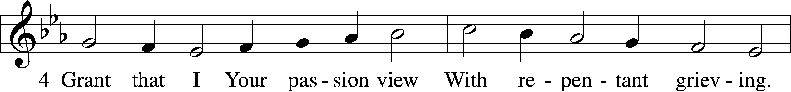
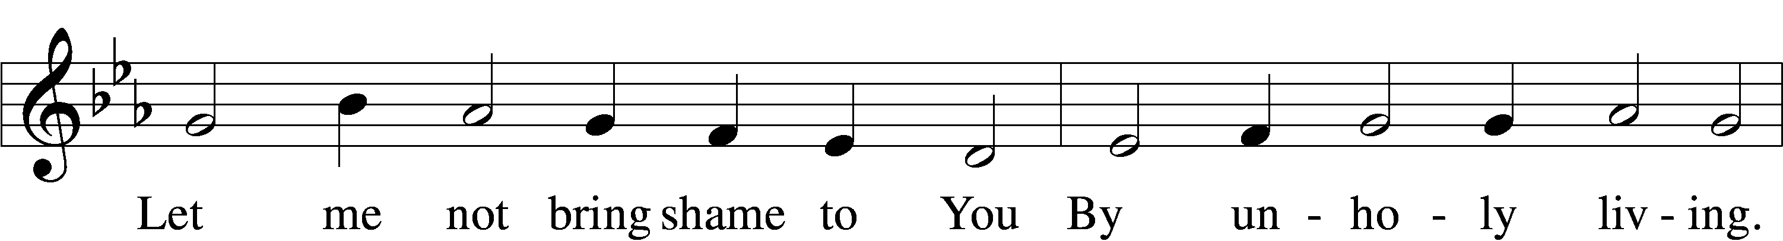
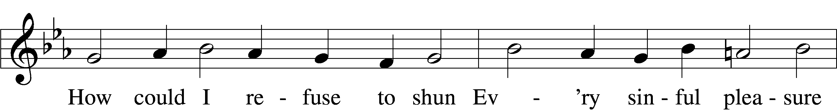
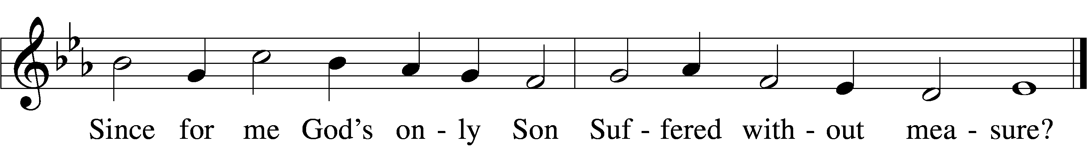
Text and tune: Public domain

THE PASSION ACCORDING TO ST. JOHN, PART FOUR John 19:1–7
¹Then Pilate took Jesus and had him flogged. ²And the soldiers wove a crown of thorns and put it on his head, and they dressed him in a purple robe. ³They kept coming up to him, saying, "Hail, King of the Jews!" and striking him on the face. ⁴Pilate went out again and said to them, "Look, I am bringing him out to you to let you know that I find no case against him." ⁵So Jesus came out, wearing the crown of thorns and the purple robe. Pilate said to them, "Here is the man!" ⁶When the chief priests and the police saw him, they shouted, "Crucify him! Crucify him!" Pilate said to them, "Take him yourselves and crucify him; I find no case against him." ⁷The Jews answered him, "We have a law, and according to that law he ought to die because he has claimed to be the Son of God."

HYMN “Jesus, I will Ponder Now” LSB 440, v.5
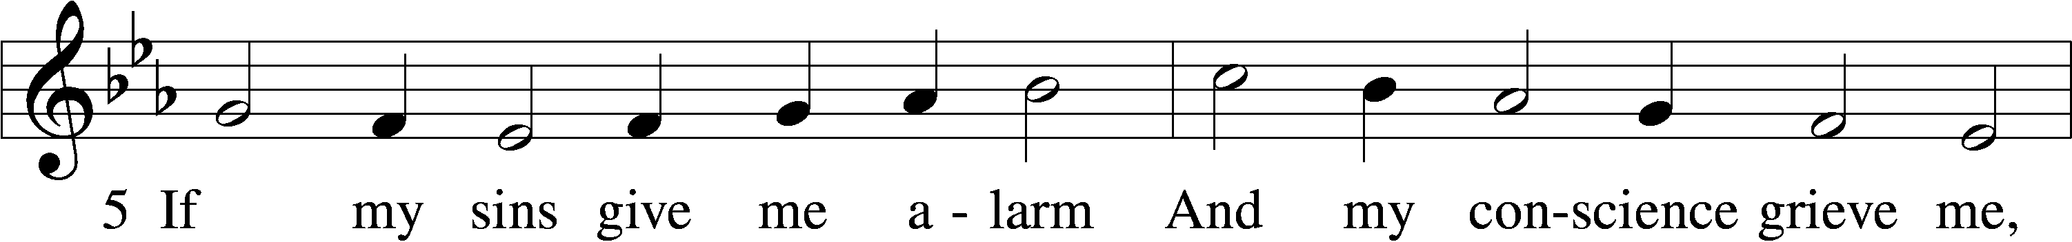
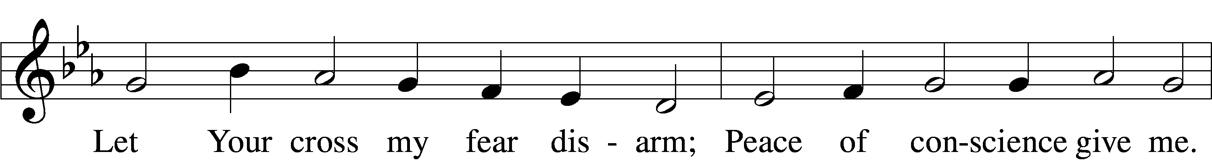
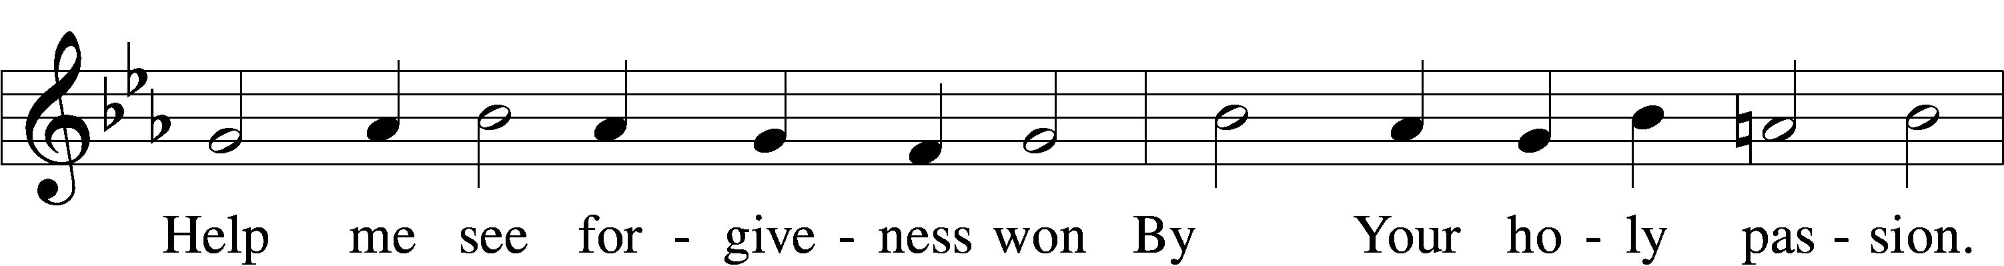
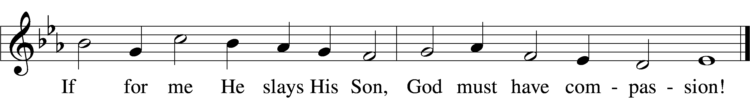
Text and tune: Public domain

THE PASSION ACCORDING TO ST. JOHN, PART FIVE John 19:8–16a
⁸Now when Pilate heard this, he was more afraid than ever. ⁹He entered his headquarters again and asked Jesus, "Where are you from?" But Jesus gave him no answer. ¹⁰Pilate therefore said to him, "Do you refuse to speak to me? Do you not know that I have power to release you, and power to crucify you?" ¹¹Jesus answered him, "You would have no power over me unless it had been given you from above; therefore the one who handed me over to you is guilty of a greater sin." ¹²From then on Pilate tried to release him, but the Jews cried out, "If you release this man, you are no friend of the emperor. Everyone who claims to be a king sets himself against the emperor." ¹³When Pilate heard these words, he brought Jesus outside and sat on the judge's bench at a place called The Stone Pavement, or in Hebrew Gabbatha. ¹⁴Now it was the day of Preparation for the Passover; and it was about noon. He said to the Jews, "Here is your King!" ¹⁵They cried out, "Away with him! Away with him! Crucify him!" Pilate asked them, "Shall I crucify your King?" The chief priests answered, "We have no king but the emperor." ¹⁶Then he handed him over to them to be crucified.
HYMN “Jesus, I will Ponder Now” LSB 440, v.6
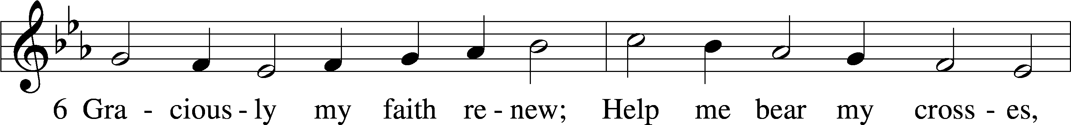
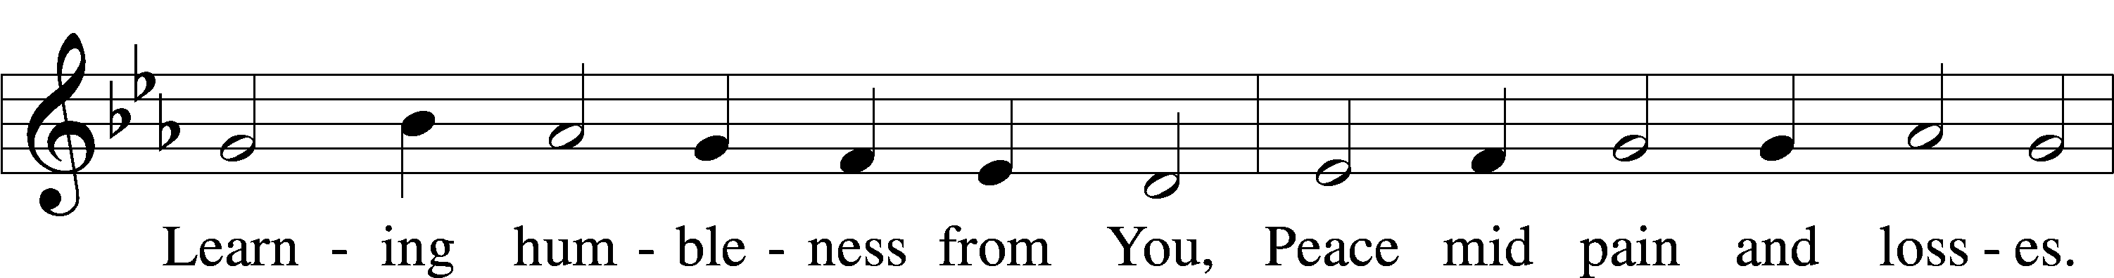
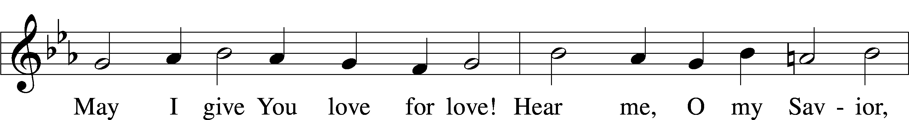
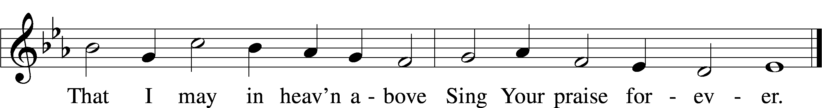
Text and tune: Public domain

THE PASSION ACCORDING TO ST. JOHN, PART SIX John 19:16b–22:16b
¹⁶So they took Jesus; ¹⁷and carrying the cross by himself, he went out to what is called The Place of the Skull, which in Hebrew is called Golgotha. ¹⁸There they crucified him, and with him two others, one on either side, with Jesus between them. ¹⁹Pilate also had an inscription written and put on the cross. It read, "Jesus of Nazareth, the King of the Jews." ²⁰Many of the Jews read this inscription, because the place where Jesus was crucified was near the city; and it was written in Hebrew, in Latin, and in Greek. ²¹Then the chief priests of the Jews said to Pilate, "Do not write, 'The King of the Jews,' but, 'This man said, I am King of the Jews.'" ²²Pilate answered, "What I have written I have written."

HYMN “Jesus, I will Ponder Now” LSB 440, v.1
Text and tune: Public domain

THE PASSION ACCORDING TO ST. JOHN, PART SEVEN John 19:23–25
²³When the soldiers had crucified Jesus, they took his clothes and divided them into four parts, one for each soldier. They also took his tunic; now the tunic was seamless, woven in one piece from the top. ²⁴So they said to one another, "Let us not tear it, but cast lots for it to see who will get it." This was to fulfill what the scripture says,
"They divided my clothes among themselves,
and for my clothing they cast lots."
²⁵And that is what the soldiers did.

SPECIAL SONG “Behold the Cross of Christ” Featuring Daniel Pinelli on violin
By Ryan Kelly, Gideon Whitehead Copyright © 2025 Gideon Whitehead and Ryan Kelly.
Used with permission. Music © 2025, Birnamwood Publications, a division of MorningStar Music
Publishers, Inc. Used with permission from onelicense.net #50-5029

THE NARRATIVE OF THE SEVEN DYING SENTENCES OF OUR LORD
Part I: “Father, Forgive Them…”
Part II: “Today YOU will be with Me in Paradise”
Part III: “Woman, Behold Your Son…”
Part IV: “My God, My God, Why Have You Forsaken Me?”
Part V: “I Thirst”
Part VI: “It is Finished”
Part VII: “Father, Into Your Hands I Commend My Spirit”

THE REMOVAL OF THE CROSS AND PASCHAL CANDLE

THE CLOSING OF THE BOOK
(A large Bible is “slammed” down on the altar representing the sealing of Jesus’ tomb in the Garden)
THE SONG OF REFLECTION “O Darkest Woe” sung by the Pastor
(After a time of prayer and meditation the congregation is invited to leave the sanctuary in silence.)

We look forward to celebrating the resurrection of our King & Savior, Jesus Christ, this Sunday with you for one of our 3 Easter services:

- 7:00 AM (Sunrise/Traditional), 9:00 AM (Traditional), 11:00 AM (Blended)
- 8:00am - 10:30am: Easter Breakfast “drop-in” buffet in the Fellowship Hall
- 10:15am: Easter Egg Hunt in the courtyard

